**ANALYSIS OF SUPPLY CHAIN MANAGEMENT SYSTEM USING LEAN SIX SIGMA WITH PERFORMANCE INDICATOR MEASUREMENT CONTROL**

|  |  |
| --- | --- |
| **Wahyu Eko Prasetyo**,  **Rita Ambarwati**,  Muhammadiyah University of Sidoarjo, Indonesia  **Correspondence**  [216110100006@umsida.ac.id](mailto:correspondingauthor@email.com)  **Received** Mmm Dd, Yyyy  **Revised** Mmm Dd, Yyyy  **Accepted** Mmm Dd, Yyyy  **Published** Mmm Dd, Yyyy  **DOI** 10.35917/tb.v22i2  Copyright © 2022 Authors. This is an open-access article distributed under the terms of the Creative Commons Attribution License. | **Abstract**  The potential for the development of the beauty product industry in Indonesia is considered very potential. The beauty product industry and trade in Indonesia is projected to increase by USD 7.5 billion with a growth of 6.5% annually for the next five years. The huge potential in the cosmetic retail business is considered to trigger competition, especially in the supply chain system which has implications for product affordability to consumers. So that this becomes an interesting condition for research as well as efforts to provide certain improvement treatments so that there is an improvement in the supply system flow in the object company. In this study, 3 layers of the research process will be carried out, namely observing and describing the existing supply chain system in the research object company, supply chain system improvement and treatment using the lean six sigma model with the stages define, measure, analyze, improve, control (DMAIC), and make observations as well as measurement of improvement results using 4 (four) balanced score card performance indicators. Excavation of data using the method of observation, interviews, scoring key performance indicators in each perspective, and study of the company's operational administration data. Based on the results of the research, the supply system based on 4 balanced-scored card indicators still has shortcomings, namely the debt to equity ratio, customer quantity and quality, internal business organization and personnel accountability. The recommendations of this study can have an improvement effect for object companies and also a reference for other companies specifically with the same segmentation.  **Keywords**: *Balanced Scored Card*, *Beauty Product Business*, *Improvement*, *Lean Six Sigma* |

# Introduction

The current era of digital transformation is marked by increasing global competition in various industrial sectors. This competition opens up competition which can have implications for the development of free trade. The complex trade competition in today's modern market, the introduction of a business product with an increasingly simple flow process procedure, as well as the increasing expectations of product users have indirectly pushed business people to start shifting their focus more and more to the organization of the supply chain system. The assumption is that the better the supply chain system that coordinates their supply system, the more effective and efficient the production performance will be within the company. The implication is that the lower the cost of the production flow they invest in and automatically the selling price that applies to consumers will also be lower and affordable.

Industry and Trade of beauty products in some literature and news is said to be one of the most promising business centers and invites a very competitive thing. Research from statista explains that the potential for the beauty and personal care market in Indonesia itself is very large, in 2021 it is projected that trade in this sector will increase to USD $ 7.5 billion with a growth of 6.5% annually for the next five years (Statista, 2021). The increase in cosmetic trade indicates that in Indonesia the public's interest in consumption of cosmetic products is very high (Satriya Candra Bondan Prabowo, 2021). The potential for the development of the beauty product industry sector in Indonesia is also a major part of the master plan and integration of national industrial development from 2015 to 2035 (Kemenperin, 2015). Capturing how much data is enough to provide an overview and at the same time the potential for highly competitive global competition in the beauty product business.

The beauty product trading business is a business that can be classified as a modern business, even though the prices of commodity products are quite temporary, but the finished products published on the market look very elastic. The facts that are happening in the market today encourage supply chain actors to adjust to market price competition. In addition, trading in beauty products is very easy for anyone to do, with a very high level of differentiation making the supply chain system very decisive later on whether the products on the market are easily affordable or not by consumers. In addition, in the past few years, more and more variants of new beauty product brands have emerged, which has decreased the cost of goods and selling a product, so that the profits earned by each sub-unit of the supply chain have also decreased. Indirectly, this condition makes business people provide added valuetowards product users by improving customer relationshipsincluding the capacity to provide additional services (Potter et al., 2004)

The method of maximizing operational functions that is adaptable to current market conditions to plan and improve an operational system is Lean Six Sigma. This systematic method can help plan and improve the processes of a business. This method uses a systematic approach that focuses on providing process value that has implications for critical areas of customer needs. This approach is considered the most appropriate for setting a customer-oriented process strategy because it has a customer satisfaction orientation that is carried out effectively. The advantage of using this system in the operation of the distribution system of goods is that it is able to minimize defects and maintain speed stability to achieve the goal standards at the highest level. The application of a systems approach in Lean and Six Sigma can improve revenue turnover through the planning, analysis, and control functions contained therein. The implication is that the more intensive use of this approach is carried out in the supply system, it will minimize delays and customer dissatisfaction. The supply chain system has the characteristics of being active and valuable, which is based on four dynamic flows, including availability, production, money and development. So that the combination method of lean six sigma with value control through 4 perspectives of the balance score card will more easily direct a business goal towards a good goal.

Previous research that supports the above opinion was carried out by (Ridwan & Noche, 2018) which measures supply chain performance in logistics companies using a lean six sigma system. The results of the study state that by using this method the company is able to create products that are fast, effective, on time and increase customer satisfaction with the certainty of orders previously agreed upon, so that product value increases and customer satisfaction also increases and the implication is increasing profits (Ari Primantara dan Hari Supriyanto, n.d.). However, this research does not identify in depth by presenting a measurement perspective on the achievement of each process, so it is not known which aspects of the indicators need to be maintained and improved. In this study, in general, the same approach will be used, namely Lean Six Sigma in the improvement process, but to test each achievement value, it is measured by a balanced score card performance indicator.

Assessment of effectiveness through key performance indicators compiled based on 4 balanced-scored card perspectives will be able to assist a management process in compiling supply chain performance measurements based on process, in this way the company will be able to assess and measure overall supply system achievement from various perspectives. In the end, the supply system improvement with the lean six sigma approach can be measured periodically and its achievement can be controlled through measurement indicators based on 4 balanced scored card perspectives.

# Literature Review and Hypotheses

In general, the scope of supply chain management is first, the product supply process from beginning to end. The picture is like the process of the main raw materials being sent from first hand to the processing company, after entering the processing process and becoming a finished product then sent to distributors, retailers, to consumers. Second, the flow of money and the like that flows from downstream to upstream and third, is the flow of information that can occur from upstream to downstream (Sariyun Naja Anwar, B. Sc, 2011). So that in this study improvements will be made to all aspects of the supply chain using the Lean Six Sigma structured performance principle so that the performance of each stage is more controlled, effective and efficient.

Lean Six Sigma is a system approach used in business operations, systematic and organized procedures to plan, identify and minimize minus components or work processes that do not add value to the production of a product (non-value added) through consistent radical development. (radical continuous improvement) in order to achieve optimal performance results (six sigma activities) (Sreedharan et al., 2018).

In the Lean Six Sigma approach using a process structure known as DMAIC through the process (Identification, measurement, analysis, development, and control). At the identification stage, perform a systemic process to define comprehensively about an object. The measurement stage focuses on the process of measuring and assigning value to an object finding, at this measurement stage a justification is also made for which parts will be the focus of measurement, how the measurement method will be, how the process and measurement system will be carried out. The Analysis stage begins to focus on analyzing the findings in the previous stage along with presenting several alternative solutions. At the development stage (improve) it focuses on the process of providing treatment or treatment to objects in accordance with the findings found in the next stage, improvements made at this stage are carried out with the aim of achieving the goals targeted at the beginning. The control stage is the stage of evaluating, assessing the achievement and control processes in the production process whether the improvements provided are effective or not. (Darwati et al., 2015)

The implication of the next improvement is measured by the Performance Indicator Balanced Scored Card (BSC) method which is also used to determine which minor and major aspects need to be the focus of attention in the next implementation. This method is an instrumentation approach procedure that is mostly used by business people to plan, describe and control an organization to realize the company's plans, steps and goals into a systemic format with a strategic measurement pattern against a set of parameters/indicators in each perspective comprehensively, so that it can improve the company's work ability to create sustainable competitive advantage(Alimudin et al., 2019). This study uses aspects of the balanced scorecard consisting of financial aspects (income growth and capital health), customer aspects (number of new customers, customer complaints and customer loyalty), internal business aspects (internal organization and innovation capabilities) and learning aspects (employee empowerment, personal accountability) (Ayu et al., 2012).

# Research Method

In this study, using a system integration process with a lean six sigma approach as process internalization, then integrated with a balanced score card perspective control. Lean six sigma is used as a treatment variable to improve quality as well as supply process systematics so as to minimize area waste (waste) at each stage of define, measure, analyze, improve and control during implementation. As a control function, the implementation of the supply system uses a measurement approach of 4 balanced scored card perspectives, namely financial, customer, business process and growth & development aspects. Excavation of data using the method of observation, interviews, scoring key performance indicators in each perspective, and study of the company's operational data administration.

Coherently the method is carried out in several stages, namely defining the CV XX supply chain system using a flow chart. Then measure supply chain performance with a CV XX measurement scope based on the key indicators of each process unit that were prepared previously. Measurement, Measurement and determination of which process unit is at least based on the accumulated value of the assessment indicators. Analyze, including critical reasons for not achieving the assessment indicators through the discovery phase and deepening of the root of the problem using the Fault Tree Analysis (FTA) method. Improvements are made to improve and at the same time increase the effectiveness and efficiency of the supply chain system using the Lean Six Sigma approach to thinking.

# Results and Discussion

1. *Define Step*

This stage discusses the general description of the existing supply chain system that is already running in the company. The supply chain system is described by a flow chart as follows;

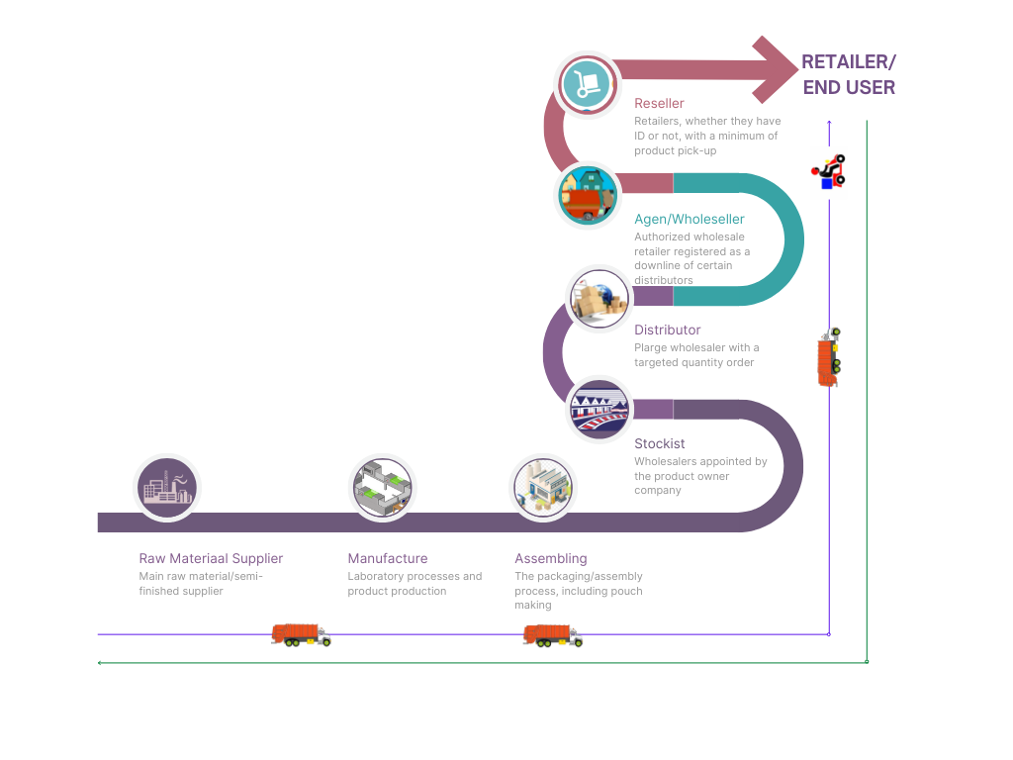

Figure 1. Supply Chain Flow Diagram

Coherently, in Figure 1 present the supply chain begins with the supply of raw materials from suppliers, the raw materials sent by several suppliers are then carried out in the manufacturing process at the main processing plant to become semi-finished goods. The assembly and packaging process is carried out in several subsidiaries and company partners before the marketing and distribution process to the next supply chain is carried out. Stockists as the main subject are appointed by the company in each province and then distribute it to their respective downline distributors according to the quantity of demand. The whole process is carried out using the main transportation owned by the company. This process continues to the next downline. Agents, wholesalers, resellers distribute products to each end user using many marketing channels. Next, observations, interviews, and more in-depth analysis are carried out to find out the values that cause waste throughout the company's supply chain. Measurements are carried out using key performance indicators that are adjusted to the company's internal characteristics using the balanced scored card measurement aspect. The results of the assessment carried out are as follows;

**Table 1. Measurement of Financial Aspects**



The results of measuring financial aspects in table 1 above show the achievement of indicators is at the level of 70% with the lowest achievement in the debt to equity ratio (capital value compared to active debt) meaning that it can be concluded simply that the company needs more capital to increase sales of its products. This is proportional to its development potential. The profit growth value of 82% shows that this beauty product agent company actually has quite promising potential.

**Table 2. Measurement of Customer Aspect**



The results of measuring customer aspects in table 2 above show the achievement of the customer aspect show that the achievement has not been maximized. Almost all appraisal indicators have values below 50% of the achievement target. The achievement of the number of new customers at 29% of the target means that the quantity of new customers who place orders at this company still really needs to be increased. This is also almost comparable to the pattern of survival of loyal customers which is at 37%, then customer complaints during the first quarter have 7x complaints with the development of reseller downlines which is still at 46%. This data shows that the marketing mix and strategy adopted by this company is still very underdeveloped. Service quality and market penetration still need to be developed using more active and customer-oriented strategies.

**Table 3. Measurement of Internal Business Aspects**



The measurement results shown in table 3 above show that the internal organizational system is still very low (8%). This is because the company is still very minimal in carrying out systematic organizational management (organizational structure, work procedures, work guidelines, and other organizational tools). The system that is run is still very familial. This raises the assumption that all components in the company are still working without systematic instructions and rules.

**Table 4. Measurement of Development and Education Aspects**



The results of measurements on the next aspect of development are shown in table 4, learning and education are seen as a whole still not fulfilled 100%. The value of personal accountability seems to be the lowest and is at 16%. The company does not seem to have a good personnel and legacy administration system. The bonding system with employees is still formed using a system of trust and kinship. This indirectly affects the certainty and accountability of personnel in the company organization.

1. Measure Step

In the next measure stage, waste identification is carried out in each appraisal aspect by considering the indicators that have the lowest values and are considered as priority improvements.

1. The minus value in the financial aspect lies in the achievement of the capital value compared to the active debt value (debt equity ratio = 37%). This shows that the health of the company's capital needs to be improved to support sales development as well as strengthen market penetration.
2. The minus value in the internal business aspect lies in the internal organization aspect. In almost all internal organizational lines, the system has not yet been formed and is more run as a family function
3. The minus value in the aspects of development and education lies in personal accountability. This arises and can be seen from the failure to achieve the existence of a work agreement and conduct system that is carried out as a control function within the company's organizational system.
4. The minus value in the aspects of development and education lies in personal accountability. This arises and can be seen from the failure to achieve the existence of a work agreement and conduct system that is carried out as a control function within the company's organizational system.
5. Analyze Step

The analyze stage is carried out by compiling the critical reasons for the non-achievement of the assessment indicators through the discovery phase and the deepening of the root of the problem using the Fault Tree Analysis (FTA) method. From this process, the main reasons and causes that need to be followed up can be identified.

1. *Fault Tree Analysis* of Financial Aspect



Figure 2. FTA diagram of financial aspects

In Figure 2 of the financial aspect FTA diagram, it shows that the potential non-achievement of financial aspects in general is caused by 4 things, namely; limited capital due to the lack of sources of venture capital, the range of product profit margins is not high, the high rate of return of investors' profits because there is no valid calculation system in accordance with the level of pure income and large enough business capital debt.

1. *Fault Tree Analysis* of Customer Aspect



Figure 3. Customer aspect FTA diagram

In Figure 3 of the customer aspect FTA diagram, it shows that the potential for unattainable customer aspects is generally caused by 4 things, namely; lack of market penetration and marketing media due to low marketing tools and channels, lacking extra service quality so that the customer experience impact is not optimal, personnel knowledge about products is minimal so they cannot provide solutions that suit customer needs, the company's upline network provides less competitive prices with market prices and the occurrence of price wars in the market that cannot be followed due to considerations of profit margins and commitments with uplines.

1. *Fault Tree Analysis* of Internal Business Aspect

Figure 7. Business internal aspect diagram

In Figure 3 of the business internal aspect FTA diagram, it shows that, the potential for not achieving internal business aspects is due to the absence of a well-organized operational system such as not having an organizational structure, not having standard operating procedures used as work guides, not having a code of conduct, manual administration system, limited digital marketing in the marketplace and social media and the majority of work tools are still manual.

1. *Fault Tree Analysis* Education and Development Aspect



Figure 8. FTA diagram of internal business aspects

In Figure 3 of the internal business aspect FTA diagram, it shows that,the potential for not achieving the education and development aspects is due to the development pattern which is still only focused on technical matters or there is no training that leads to psychological matters, the company does not have any legality related to employees so that it is vulnerable to fraud, lacks trust from company owners, making it difficult for personnel to develop, and employee acceptance system that is still family so that it has implications for the quality and credibility of personnel.

1. Improve Step

Based on the results of the analysis using a fault tree analysis shows several things that affect the less than optimal performance of the company's organization. So from this analysis, the research raises several suggestions and recommendations for improvement so that some negative aspects can be minimized. The suggestions and recommendations are presented in the following table;

**Table 4. Recomendation**





The suggestions and recommendations for improvement above can be made in accordance with the level of urgency and consideration of the capacity of the company's resources. The evaluation findings and recommendations are based on the findings and analysis carried out by researchers so that it is still very possible to be re-evaluated and developed into a form that is more practical and adaptable to the conditions of the company at that time.

1. Control Step

The last stage of the analysis and improvement module is to evaluate, assess and prepare the next improvement plan. The achievement assessment and control process in this process serves to assess whether the improvements provided have been effective or not. The achievement assessment system can be seen by conducting the same analysis as the steps carried out above or by creating a new, simpler parameter in the form of key performance indicators in each aspect that was decided to be carried out at that time by the company.

# Conclusion

The results of research on the analysis of supply chain management systems in the research object company using a lean six sigma work organization pattern produce evaluation data and recommendations. Through the 4 aspects of the balanced score card, it was found that the weak point is in the strength of capital and the value of debt owned, so the company must be able to increase its capital capacity by increasing sources and healthier cash flow while taking in to account the implications of the value of trade payables which are used as working capital in a comprehensive manner. balanced. Then on the customer side, the company needs to increase its market penetration capability by increasing marketing channels, its function is to increase the probability of increasing profits. In the aspect of internal business, it has weaknesses in terms of administrative and organizational systems, this arises because the company is too pessimistic so that it carries out more family-friendly work functions, the recommendation is that the company must reverse the paradigm by establishing a more systematic system. The latter in the education and development aspect shows that personnel capacity and accountability are not yet fit, so companies need to penetrate and focus more programming on improving personnel capabilities so that they can have positive implications for other aspects. With this research findings module, companies can add and collaborate with other approaches and recommendations for future research in order to further develop the scope of company segmentation with a more comprehensive approach.

# References

Alimudin, A., Falani, A. Z., Mudjanarko, S. W., & Limantara, A. D. (2019). Analisis Pengaruh Penerapan Perspektif Balanced Scorecard Terhadap Peningkatan Kinerja UMKM. *Ekonika : Jurnal Ekonomi Universitas Kadiri*, *4*(1). https://doi.org/10.30737/ekonika.v4i1.337

Ari Primantara dan Hari Supriyanto. (n.d.). *PENGUKURAN DAN PENINGKATAN PERFORMANSI SUPPLY CHAIN DENGAN PENDEKATAN MODEL SCOR DAN LEAN SIX SIGMA DI PT. GUNAWAN DIANJAYA STEEL, SURABAYA*.

Ayu, G., Asri, M., & Putri, D. (2012). Nomor 3 Halaman 334-501 Malang. *Jurnal Akuntansi Multiparadigma JAMAL*, *3*.

Darwati, L., Mustafid, M., & Suparti, S. (2015). Pendekatan Servqual-Lean Six Sigma Menggunakan Diagram Kontrol T2 Hotelling Untuk Meningkatkan Kualitas Pelayanan Pendidikan (Studi Kasus Di Jurusan Statistika Universitas Diponegoro). *Jurnal Gaussian*, *4*(2).

Kemenperin. (2015). Rencana Induk Pembangunan Industri Nasional 2015 - 2035. *Rencana Induk Pembangunan Industri Nasional 2015-2035*.

Potter, A., Mason, R., Naim, M., & Lalwani, C. (2004). The evolution towards an integrated steel supply chain: A case study from the UK. *International Journal of Production Economics*, *89*(2). https://doi.org/10.1016/S0925-5273(02)00449-8

Ridwan, A., & Noche, B. (2018). Model of the port performance metrics in ports by integration six sigma and system dynamics. *International Journal of Quality and Reliability Management*, *35*(1). https://doi.org/10.1108/IJQRM-03-2016-0041

Sariyun Naja Anwar, B.Sc, M. M. A. (2011). Manajemen Rantai Pasokan (Supply Chain Management) : Konsep Dan Hakikat. *Jurnal Dinamika Informatika*, *3*(2).

Satriya Candra Bondan Prabowo, , SE., MM. (2021). *Analisis Financial Distress Menggunakan Pendekatan Model Altman (Z-Score) Dan Zmijewski (X-Score) (Studi Pada Perusahaan Manufaktur Sektor Industri Barang Konsumsi Sub Sektor Kosmetik Dan Barang Keperluan Rumah Tangga Yang Terdaftar Di Bursa Efek Indonesia Periode 2015-2019)*. Universitas Brawijaya Malang.

Sreedharan, V. R., Gopikumar, G. v., Nair, S., Chakraborty, A., & Antony, J. (2018). Assessment of critical failure factors (CFFs) of Lean Six Sigma in real life scenario: Evidence from manufacturing and service industries. *Benchmarking*, *25*(8). https://doi.org/10.1108/BIJ-10-2017-0281

Statista. (2021). *Indonesia : revenue of beauty & personal care 2017-2025 Revenue of the beauty & personal care market in Indonesia from 2017 to 2025*. Statista Research Department.